**Project Design Phase-II**

**Technology Stack (Architecture & Stack)**

|  |  |
| --- | --- |
| Date | 03 October 2022 |
| Team ID | PNT2022TMID50825 |
| Project Name | Project – Personal Expense Tracker Application |
| Maximum Marks | 4 Marks |

**Technical Architecture:**

The Deliverable shall include the architectural diagram as below and the information as per the table1 & table 2

**Example: Processing of the personal expense tracker application**

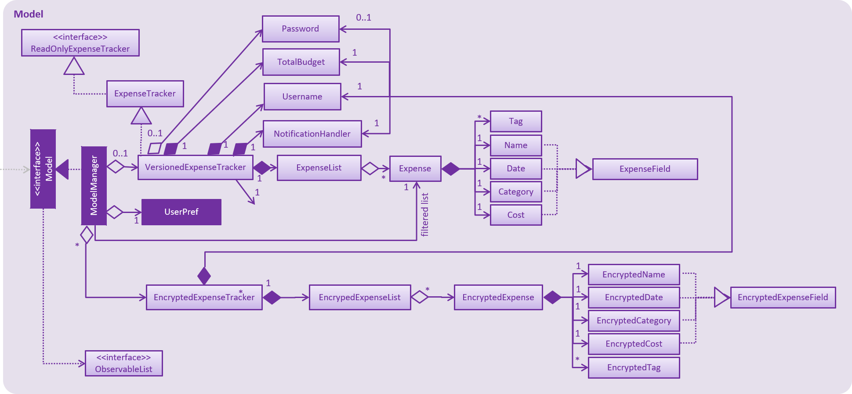

Guidelines:

1. Building an alerting algorithm
2. Provide the essential storage component
3. Indicate external interfaces if available
4. Indicate the communication platforms
5. Indicate interface for the cloud web design

**Table-1 : Components & Technologies:**

|  |  |  |  |
| --- | --- | --- | --- |
| **S.No** | **Component** | **Description** | **Technology** |
|  | Display page | How user interacts with application | HTML, CSS, JavaScript |
|  | Login | Login for a process in the application | Java |
|  | Password verification | Process for verifying the user password | IBM Watson Assistant |
|  | Check data base | Checking the user account balance | IBM Watson Assistant |
|  | Cloud Database | Storing the user and account information on cloud | IBM DB2, IBM Cloud |
|  | File Storage | Storing the user and account information on hard drive | IBM Block Storage or Other Storage Service or Local Filesystem |
|  | ID proof verification | Verification of user bank details and identity | Aadhar and Bank ID API |
|  | Cloud web interface | Providing the communication between the user and account expenses | Local, Cloud Foundry, Kubernetes |

**Table-2: Application Characteristics:**

| **S.No** | **Characteristics** | **Description** | **Technology** |
| --- | --- | --- | --- |
|  | Open-Source Frameworks | Java and IBM cloud | IBM technology |
|  | Availability | Provides the easy access almost to all users | Android |
|  | Performance | Produces high efficiency alerts | Monitoring algorithm |